**Prodigy Infotec Internship**

**Task 1:** Caesar Cipher

**Submitted by:** Saira Arshad

**Internship ID:** CIN: PIT/AUG25/00470

**Date:** August 2025

**Duration :** 1 month

**Table of Contents** 

1. Introduction-----------------------------------------------------------------------
2. Objective --------------------------------------------------------------------------
3. Code Explanation ---------------------------------------------------------------
4. Output Screenshot placeholder -----------------------------------------------
5. Conclusion-------------------------------------------------------------------------

**1. Project Objective**

This project implements a simple Caesar Cipher encryption and decryption program in Python. The Caesar Cipher is a classical substitution cipher where each letter in the plaintext is shifted a fixed number of positions.

**2.Objective**

The main goal is to:

* Take a message and shift value from the user
* Encrypt or decrypt the message using Caesar Cipher logic
* Display the result in the terminal

**3. Code Explanation**

**encrypt(text, shift)**: Shifts each alphabetic character by the shift value.

**decrypt(text, shift)**: Calls encrypt() with a negative shift.

Non-alphabetic characters (e.g., spaces, punctuation) are preserved.

A main function prompts the user to select encryption or decryption.

**Python Code Used (Short Snippet)**

***python***

def encrypt(text, shift):

encrypted_text = ""

for char in text:

if char.isalpha():

base = ord('A') if char.isupper() else ord('a')

encrypted_text += chr((ord(char) - base + shift) % 26 + base)

else:

encrypted_text += char

return encrypted_text

def decrypt(text, shift):

return encrypt(text, -shift)

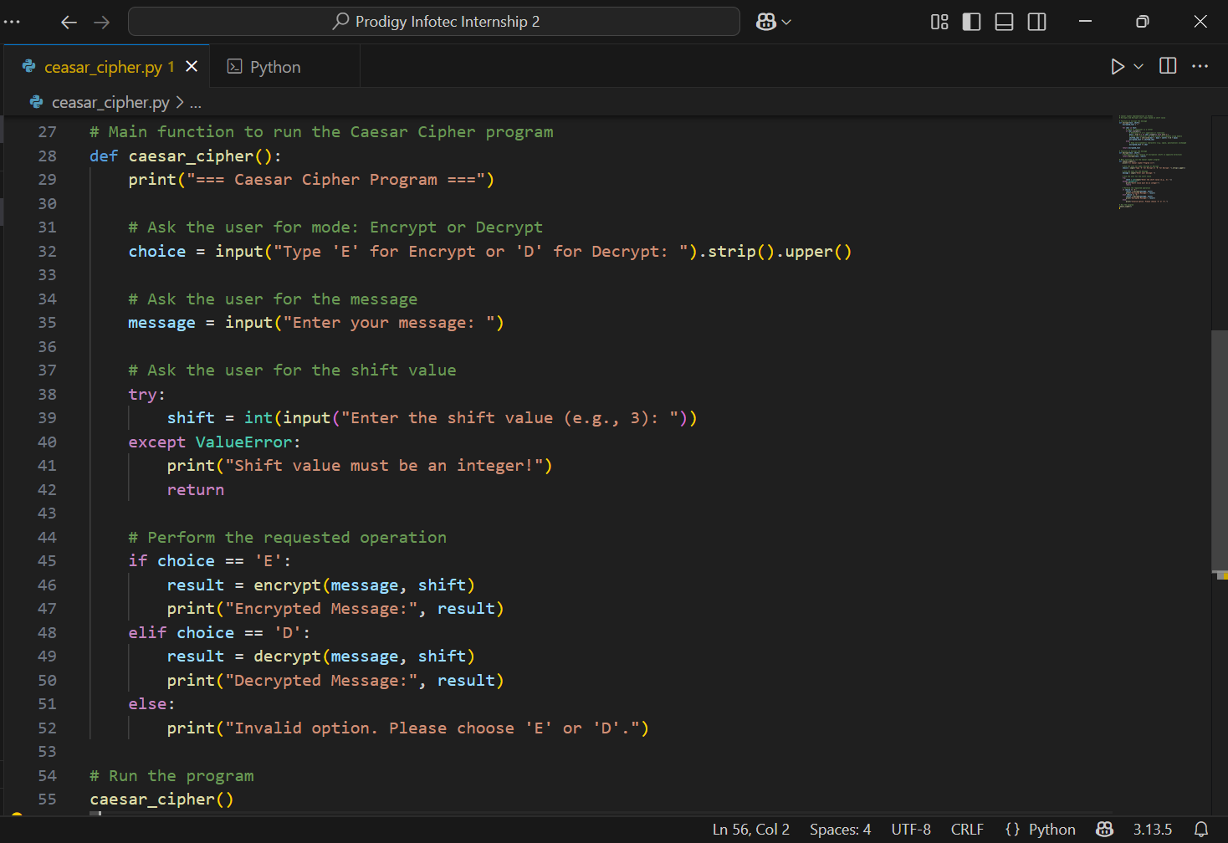

**5. Output Samples**

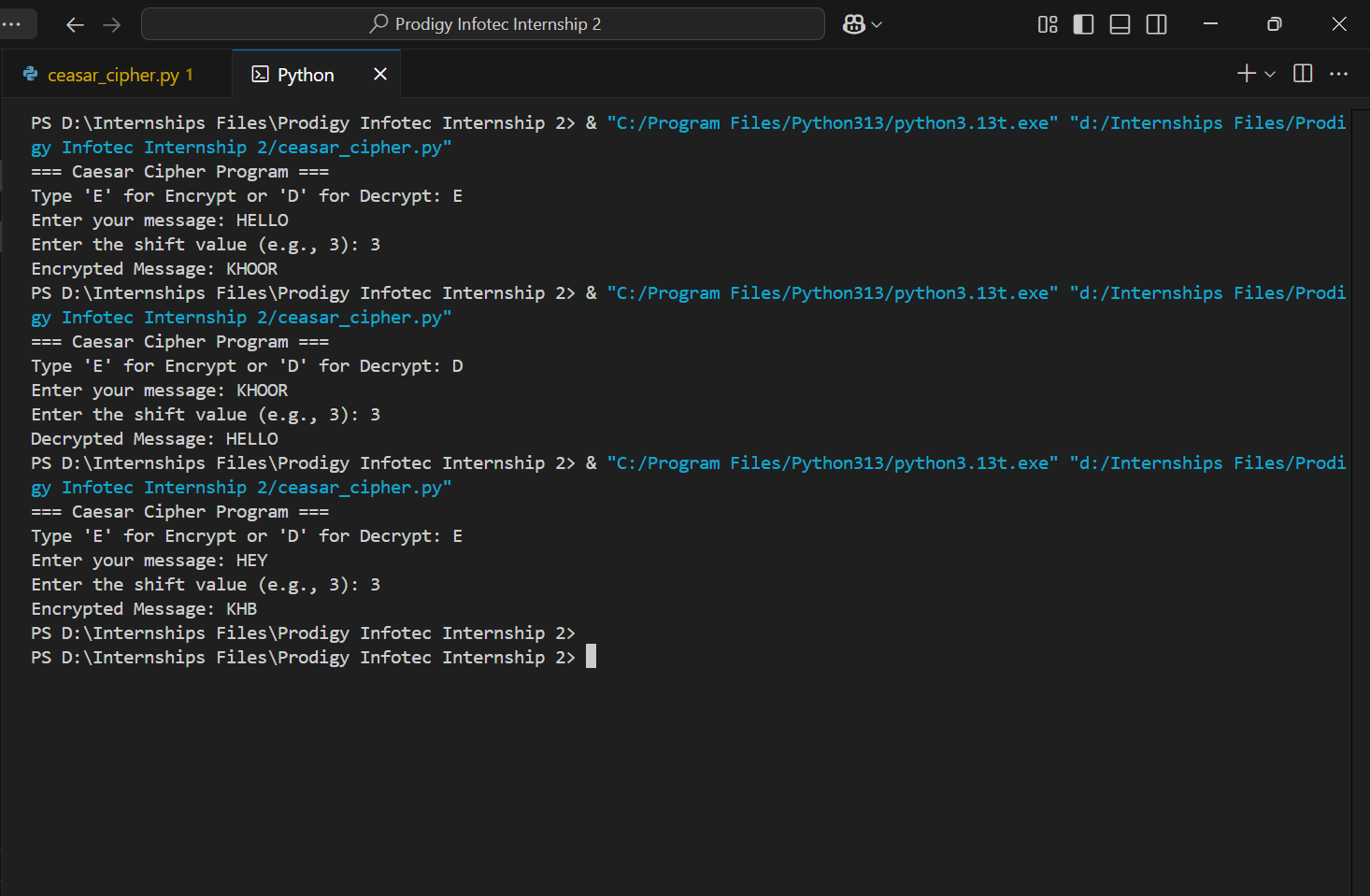

**7.Conclusion**

This task demonstrates:

* Basic encryption principles using Caesar Cipher
* User interaction via terminal
* Control structures, string manipulation, and modular arithmetic in Python

**8. Submission Info** 

Name: Saira Arshad

Internship: Prodigy Infotech Cybersecurity Internship

Task: Task 1 - Ceasar cipher pythan program

Date of Submission: August 2025